Silhouette metric for img011001.jpg is: 0.7213160404680397

Davies Bouldin metric for img011001.jpg is: 0.24910960317363096

Calinski Harabasz metric for img011001.jpg is: 51380.13939969807

ID 0: (103, 477)

ID 1: (934, 863)

ID 2: (890, 656)

ID 3: (1374, 557)

ID 4: (1013, 514)

ID 5: (1130, 574)

ID 6: (905, 439)

ID 7: (1736, 445)

ID 8: (1556, 450)

ID 9: (965, 292)

ID 10: (1040, 175)

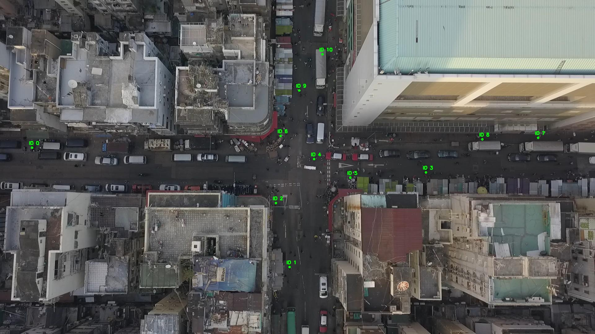

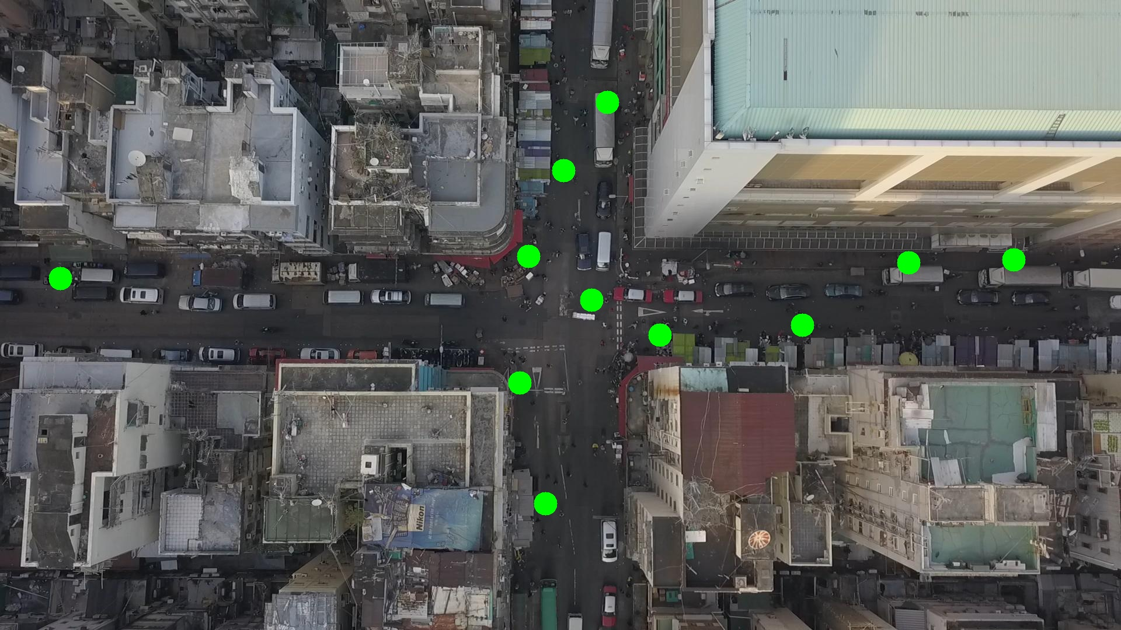

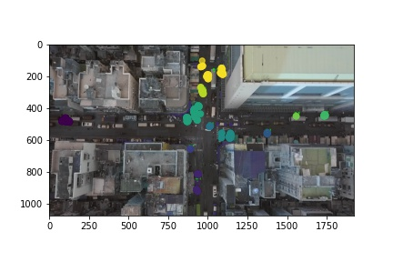

Silhouette metric for img011002.jpg is: 0.7062290179810234

Davies Bouldin metric for img011002.jpg is: 0.2461681669923541

Calinski Harabasz metric for img011002.jpg is: 35628.30773476177

ID 0: (102, 479)

ID 1: (936, 844)

ID 2: (890, 655)

ID 3: (1373, 559)

ID 4: (1012, 514)

ID 5: (1119, 575)

ID 6: (900, 439)

ID 7: (1736, 445)

ID 8: (1551, 448)

ID 9: (965, 292)

ID 10: (1028, 205)

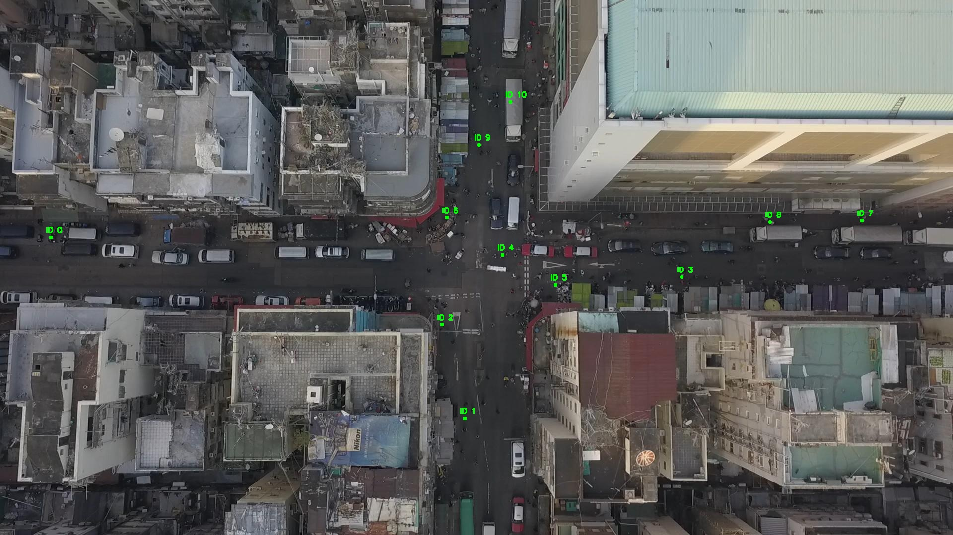

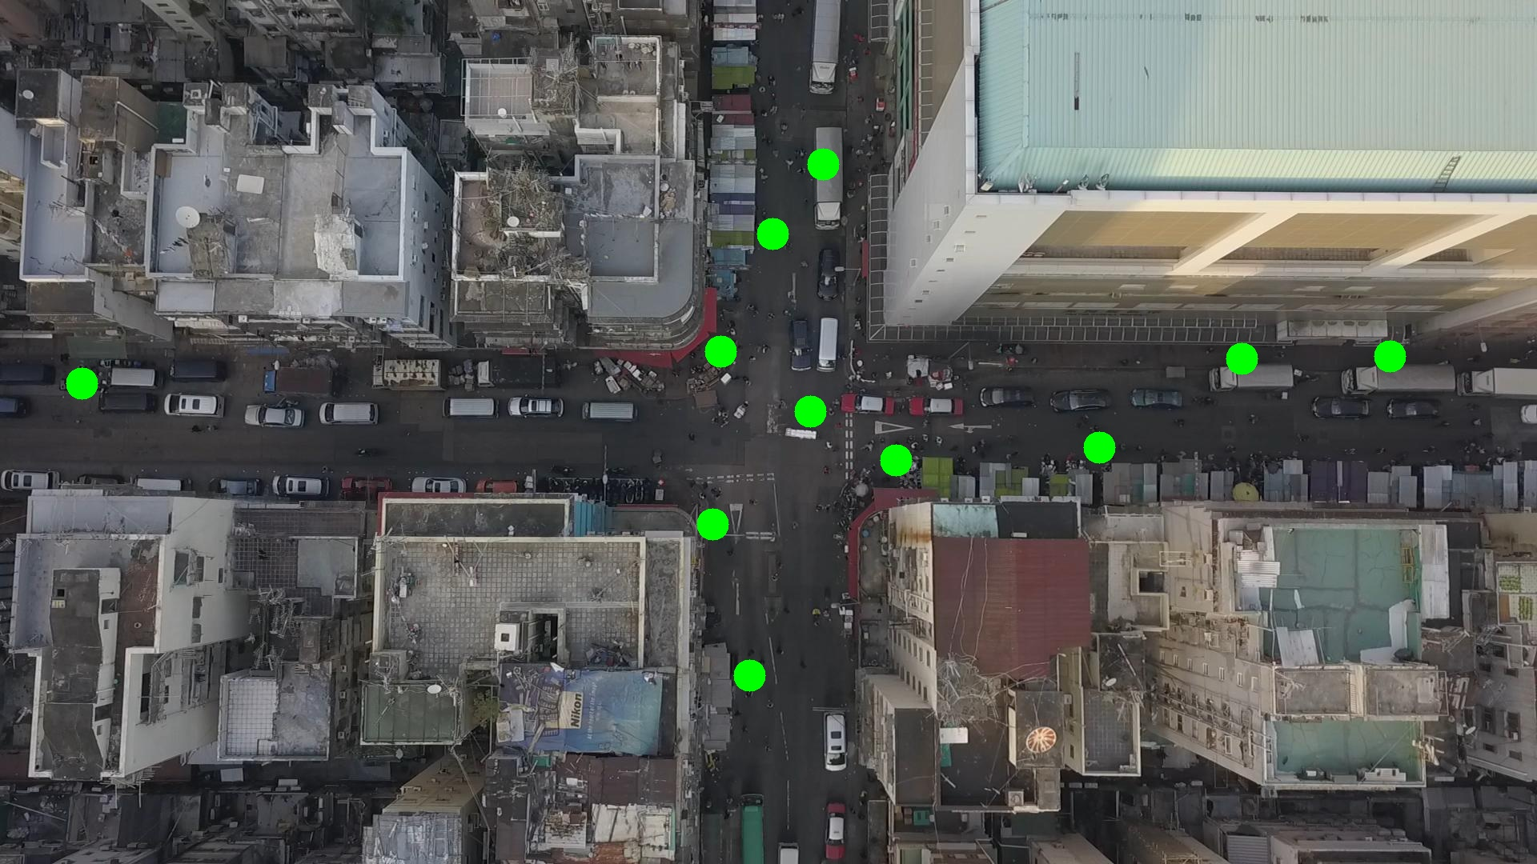

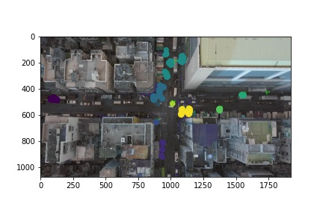

Silhouette metric for img011003.jpg is: 0.6791902190179963

Davies Bouldin metric for img011003.jpg is: 0.29341849313512475

Calinski Harabasz metric for img011003.jpg is: 37749.06251744528

ID 0: (100, 479)

ID 1: (937, 831)

ID 2: (890, 656)

ID 3: (1376, 555)

ID 4: (1012, 514)

ID 5: (1079, 552)

ID 6: (903, 420)

ID 7: (1736, 445)

ID 8: (1562, 451)

ID 9: (964, 290)

ID 10: (1054, 185)

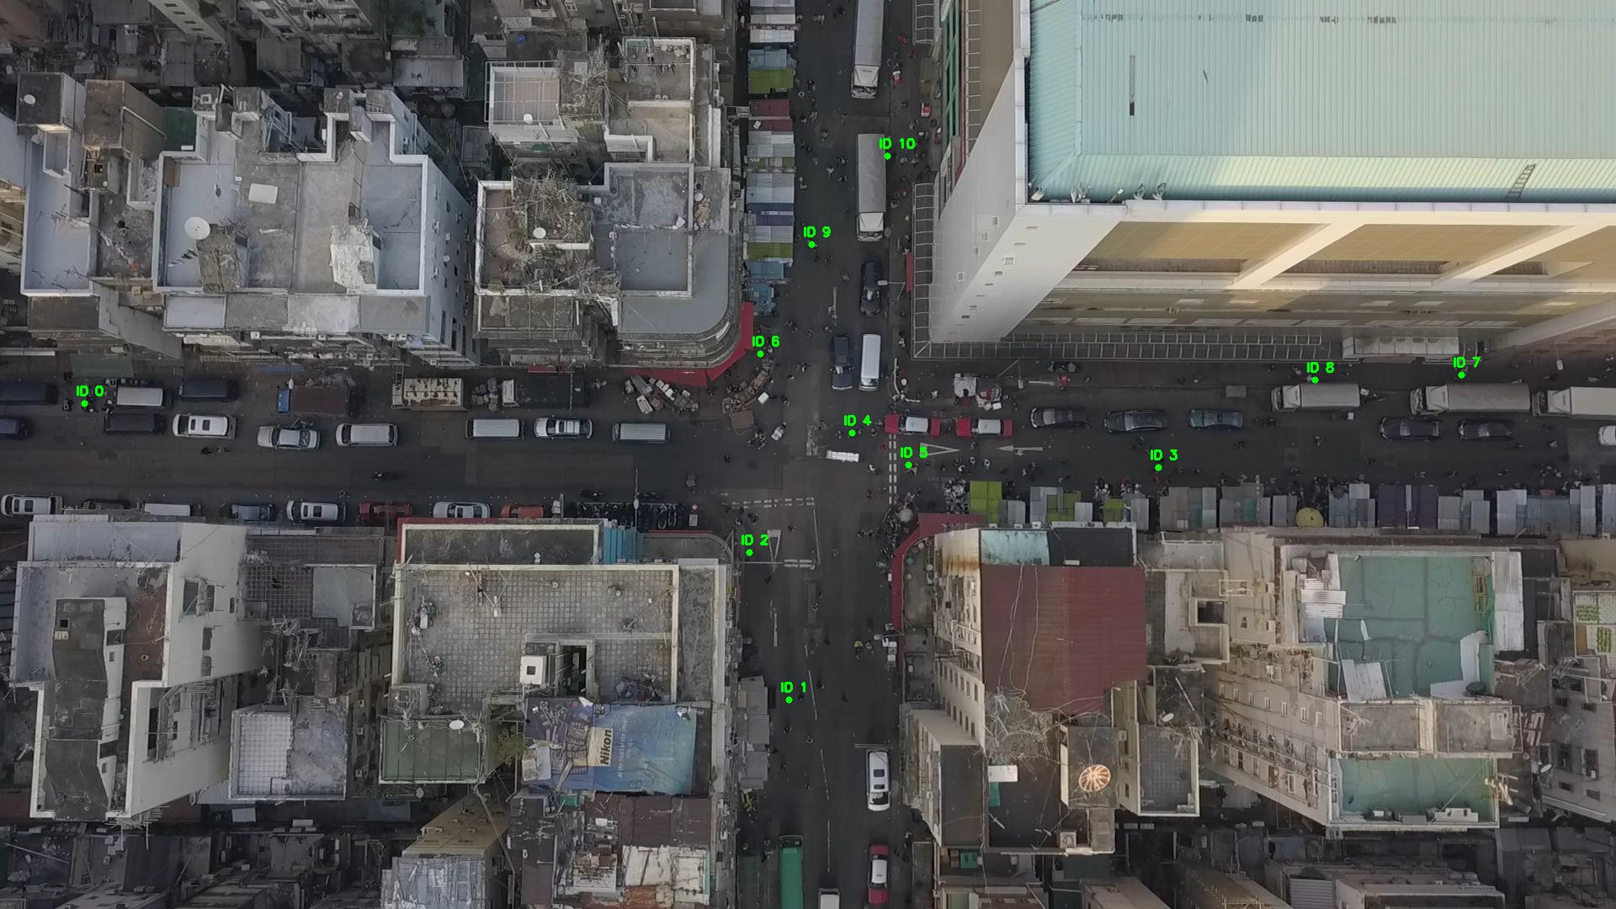

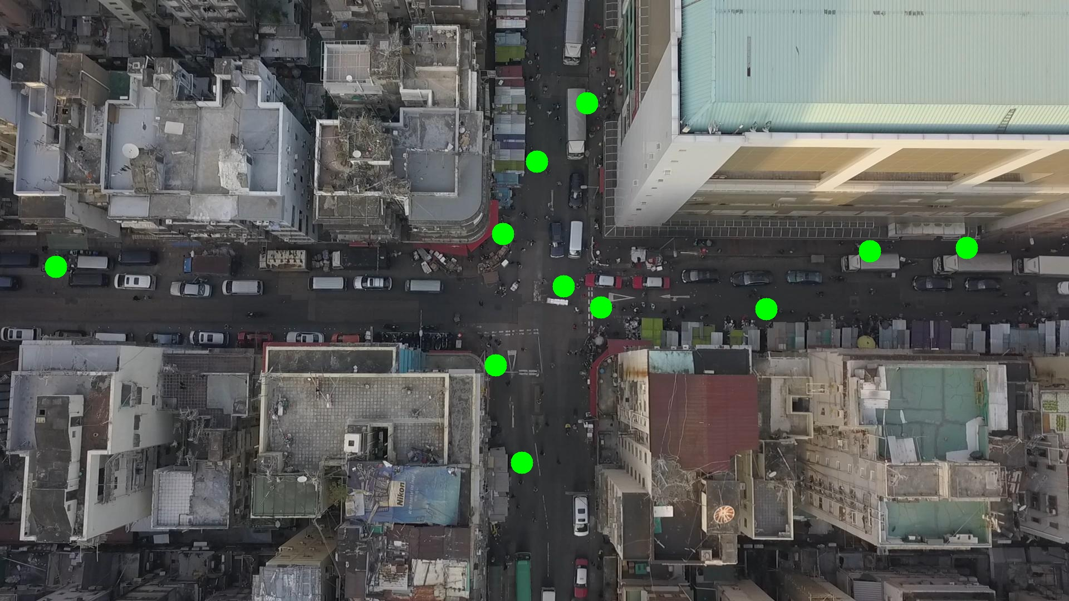

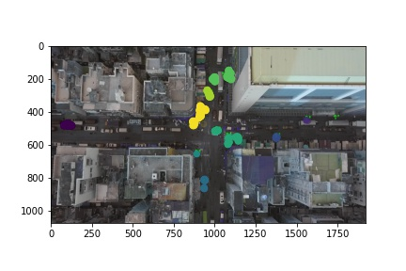

Silhouette metric for img011004.jpg is: 0.6913585750296574

Davies Bouldin metric for img011004.jpg is: 0.3196176453034643

Calinski Harabasz metric for img011004.jpg is: 53457.091139128905

ID 0: (101, 478)

ID 1: (937, 816)

ID 2: (890, 655)

ID 3: (1375, 556)

ID 4: (1012, 515)

ID 5: (1114, 566)

ID 6: (904, 430)

ID 7: (1736, 445)

ID 8: (1562, 451)

ID 9: (964, 290)

ID 10: (1056, 185)

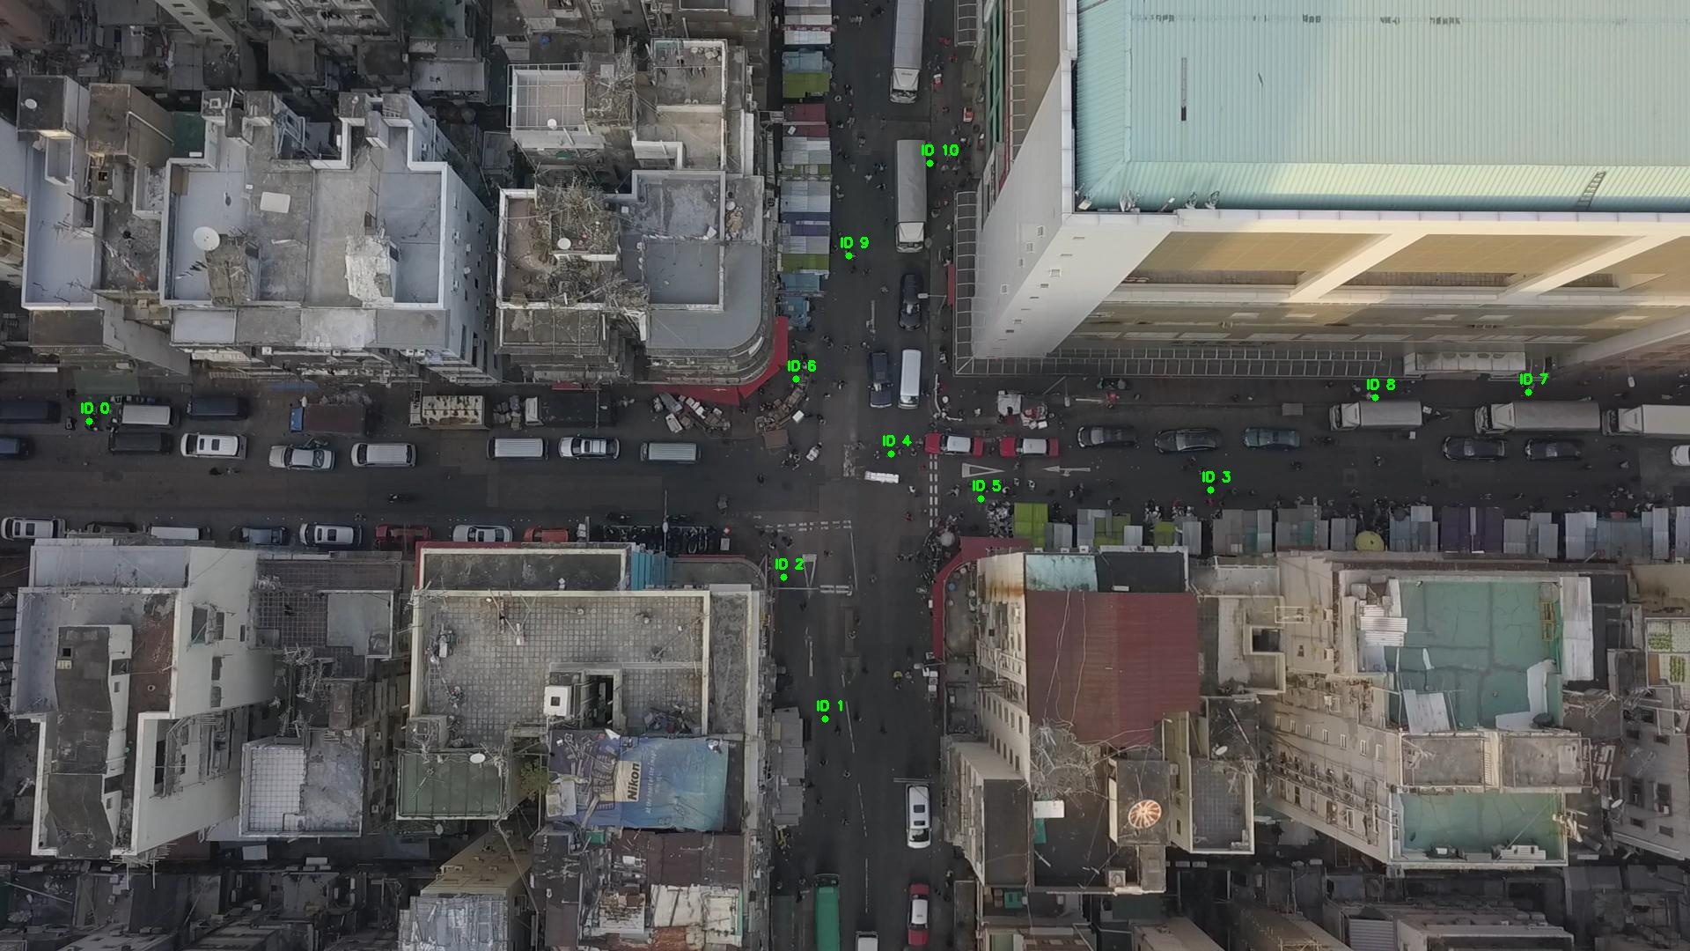

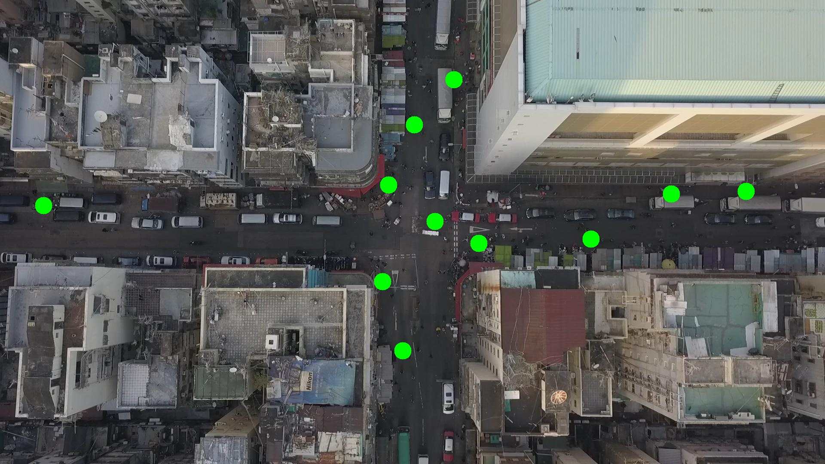

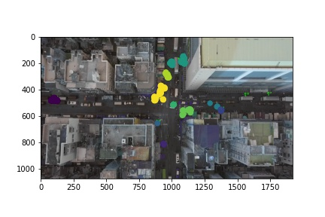

Silhouette metric for img011005.jpg is: 0.6234496154260396

Davies Bouldin metric for img011005.jpg is: 0.35471301274818906

Calinski Harabasz metric for img011005.jpg is: 22403.58149818595

ID 0: (103, 477)

ID 1: (935, 862)

ID 2: (891, 654)

ID 3: (1376, 555)

ID 4: (1012, 515)

ID 5: (1110, 569)

ID 6: (904, 430)

ID 7: (1736, 445)

ID 8: (1562, 451)

ID 9: (975, 283)

ID 10: (1056, 185)

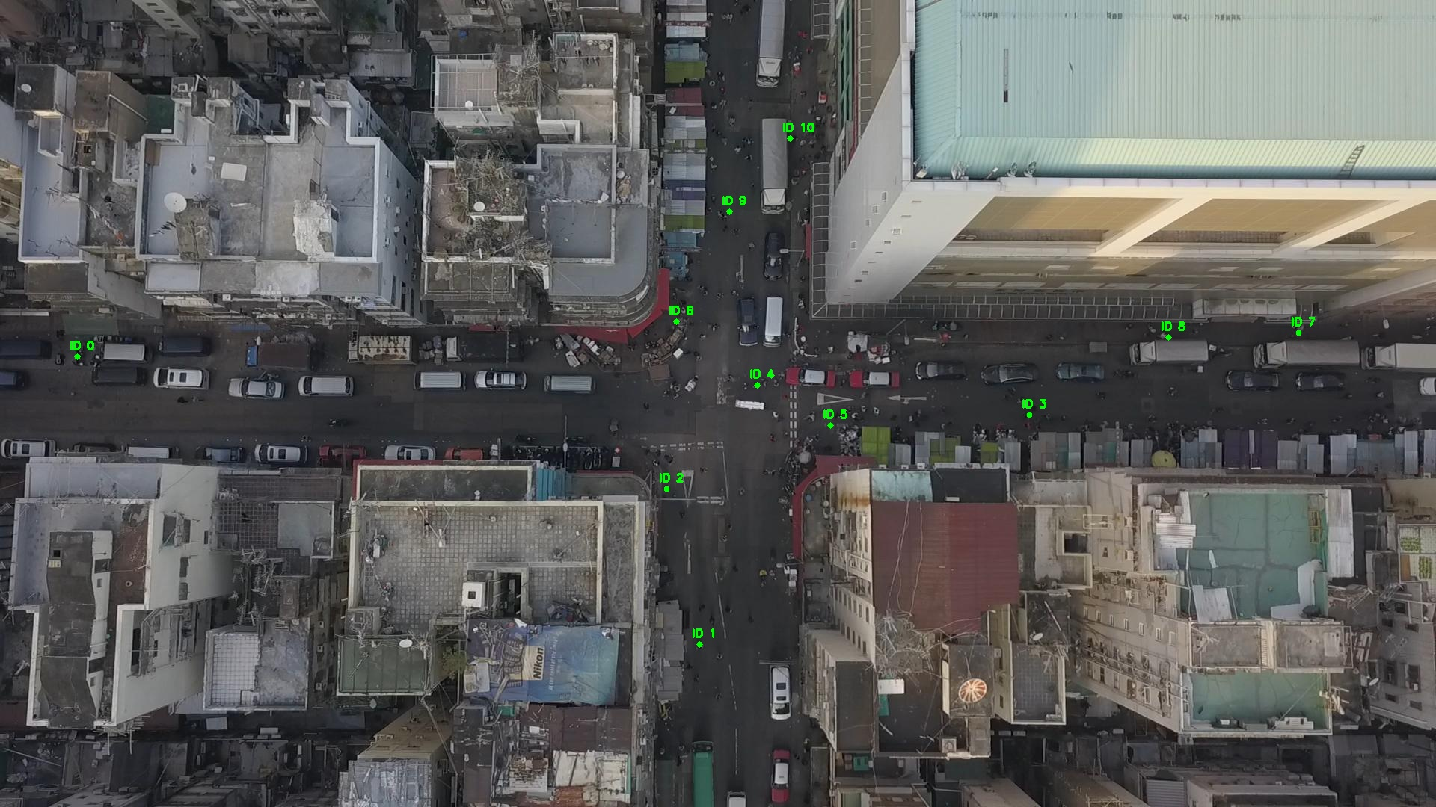

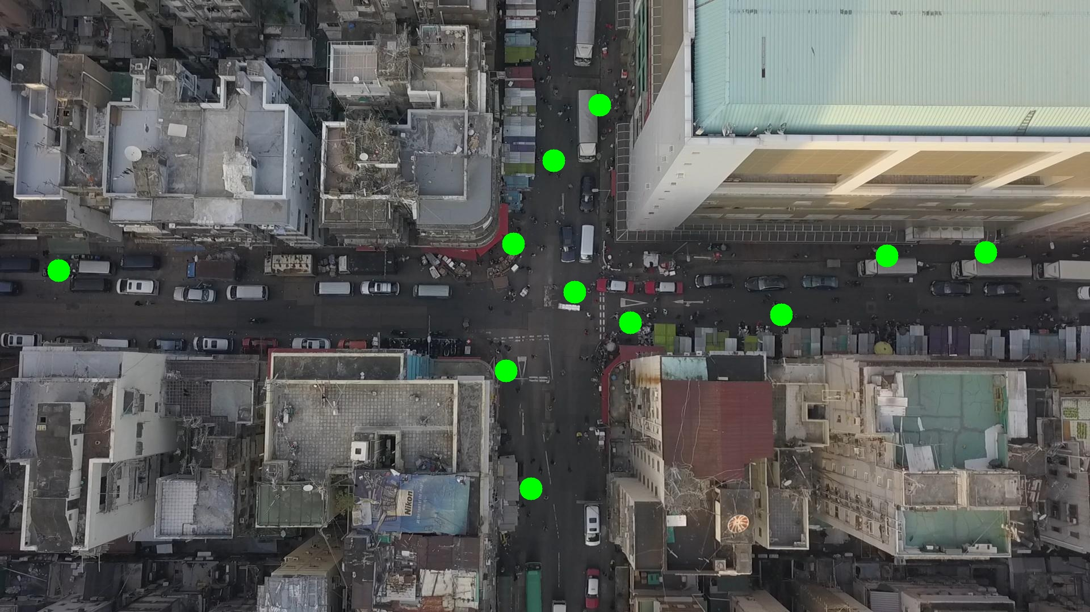

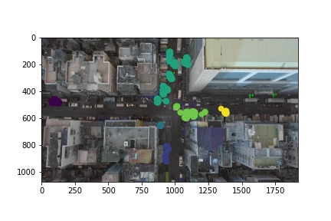

Silhouette metric for img011006.jpg is: 0.4050040066022024

Davies Bouldin metric for img011006.jpg is: 0.456019998771941

Calinski Harabasz metric for img011006.jpg is: 21868.291931938864

ID 0: (103, 478)

ID 1: (938, 858)

ID 2: (892, 655)

ID 3: (1362, 539)

ID 4: (1011, 513)

ID 5: (1132, 574)

ID 6: (932, 474)

ID 7: (1736, 445)

ID 8: (1562, 451)

ID 9: (972, 281)

ID 10: (1056, 185)

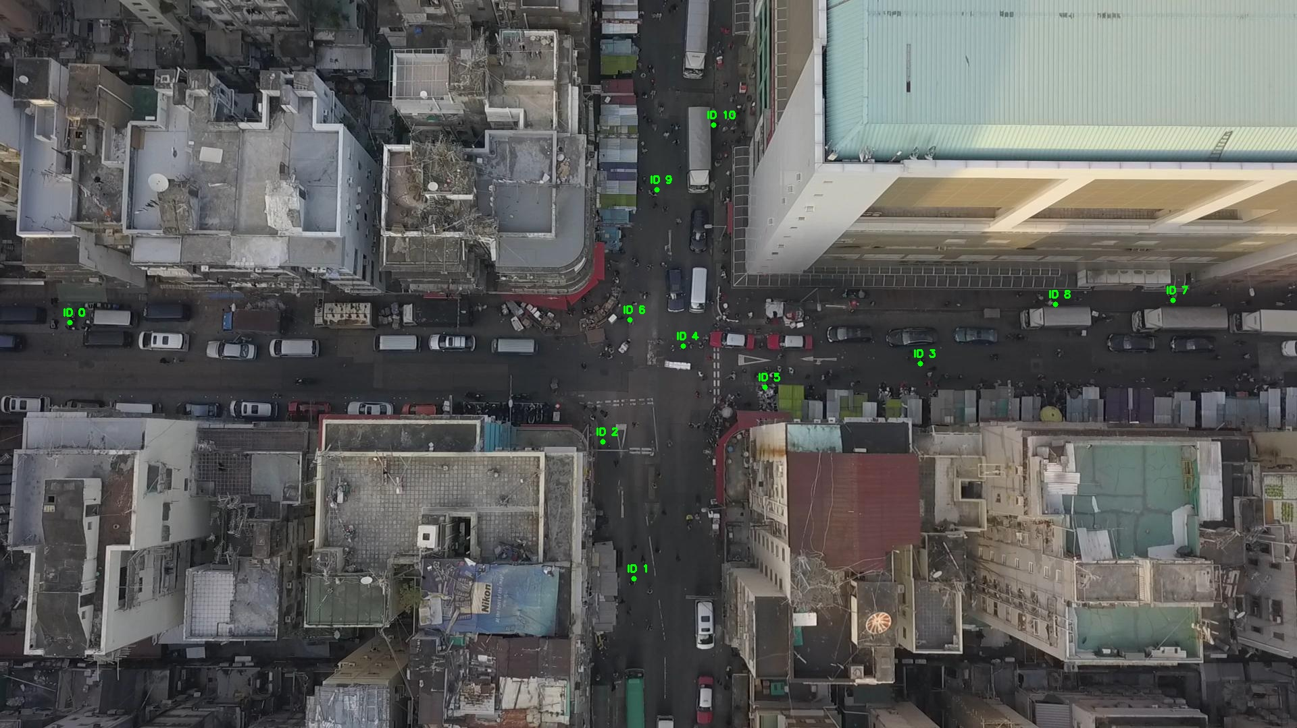

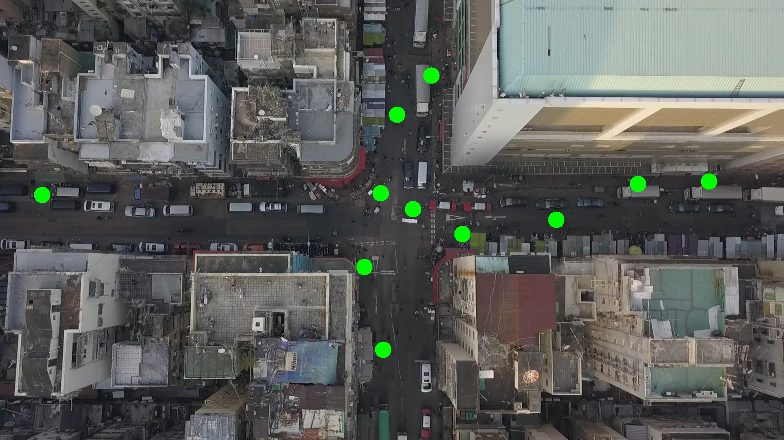

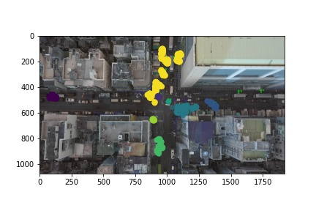

Silhouette metric for img011007.jpg is: 0.384308323517864

Davies Bouldin metric for img011007.jpg is: 0.5244203025055918

Calinski Harabasz metric for img011007.jpg is: 24082.167587492513

ID 0: (103, 477)

ID 1: (938, 865)

ID 2: (892, 654)

ID 3: (1367, 543)

ID 4: (1011, 513)

ID 5: (1128, 579)

ID 6: (932, 474)

ID 7: (1736, 445)

ID 8: (1562, 451)

ID 9: (979, 299)

ID 10: (960, 130)

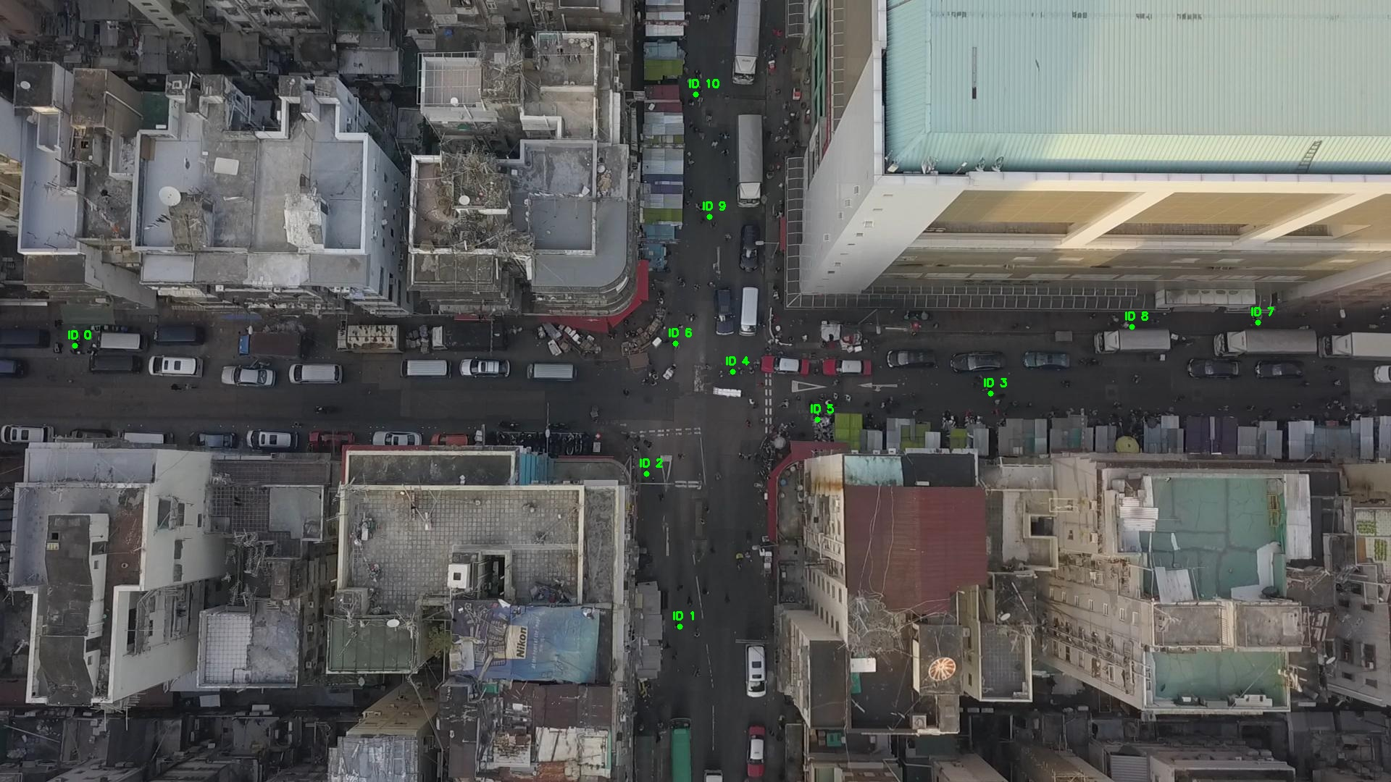

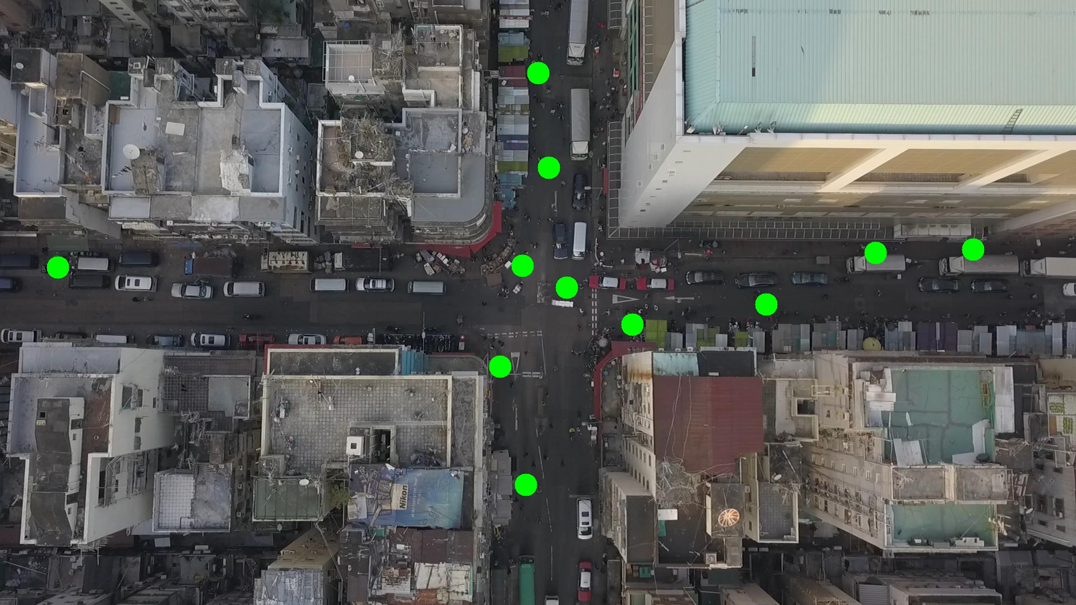

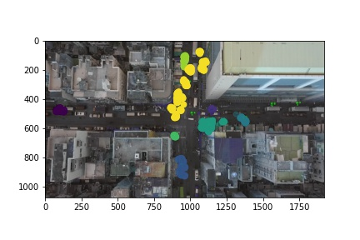

Silhouette metric for img011008.jpg is: 0.4195096923465476

Davies Bouldin metric for img011008.jpg is: 0.4983886677609734

Calinski Harabasz metric for img011008.jpg is: 26696.919153921146

ID 0: (103, 478)

ID 1: (936, 864)

ID 2: (892, 653)

ID 3: (1368, 547)

ID 4: (1011, 513)

ID 5: (1127, 562)

ID 6: (888, 501)

ID 7: (1736, 445)

ID 8: (1530, 451)

ID 9: (994, 263)

ID 10: (959, 135)

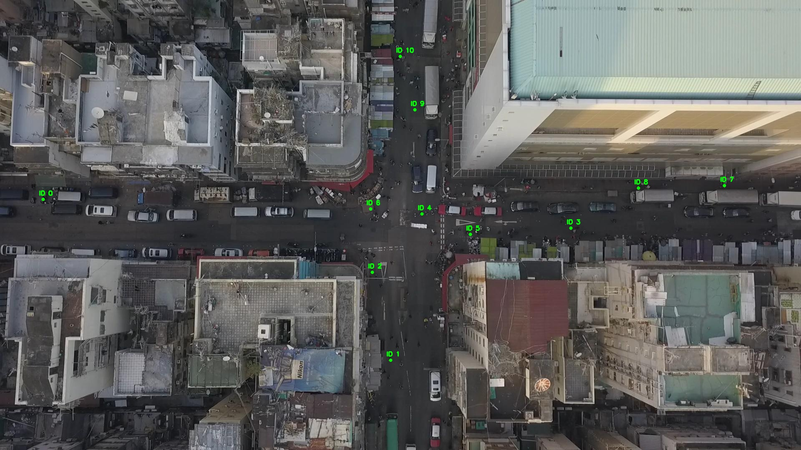

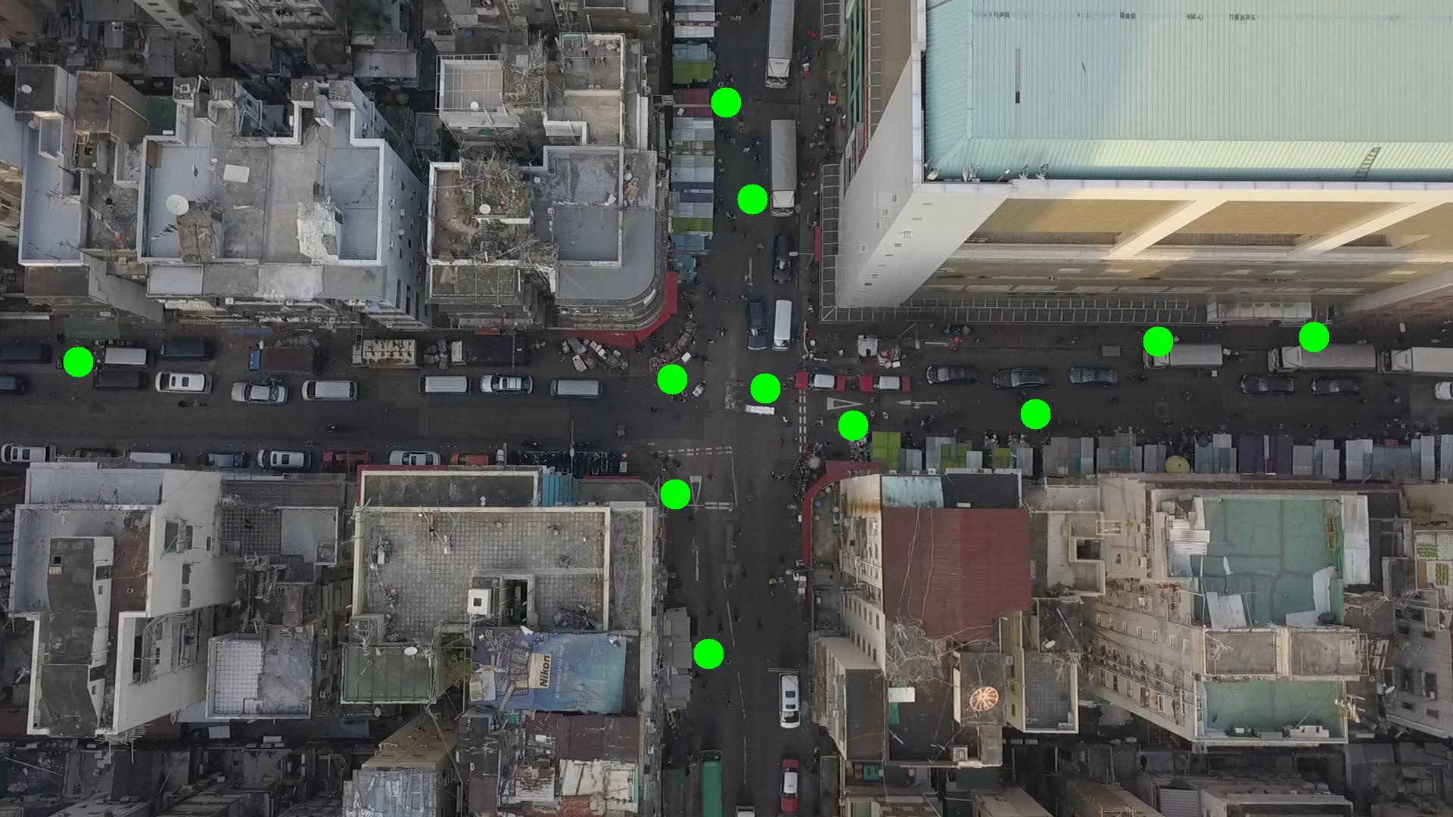

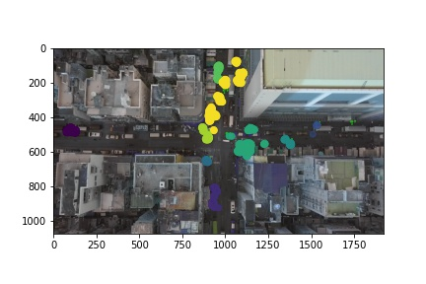

Silhouette metric for img011009.jpg is: 0.6546751387033956

Davies Bouldin metric for img011009.jpg is: 0.29081974036252217

Calinski Harabasz metric for img011009.jpg is: 58366.164164827795

ID 0: (104, 477)

ID 1: (938, 862)

ID 2: (891, 651)

ID 3: (1373, 549)

ID 4: (1066, 468)

ID 5: (1120, 586)

ID 6: (912, 428)

ID 7: (1736, 445)

ID 8: (1530, 447)

ID 9: (1007, 194)

ID 10: (959, 135)

ID 11: (1073, 1007)

ID 12: (1235, 1044)

ID 13: (1146, 468)

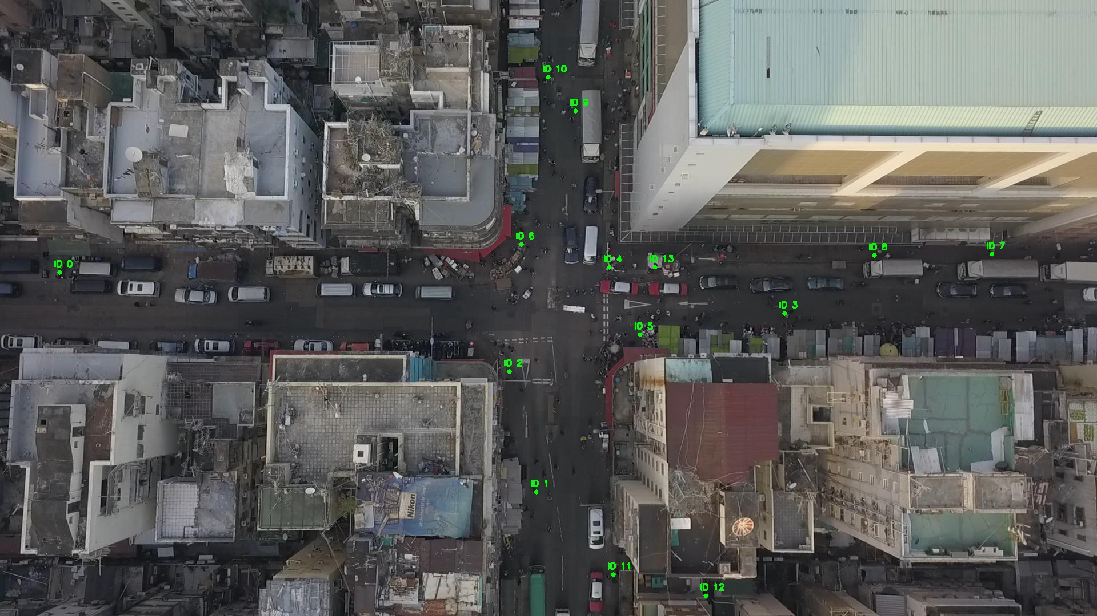

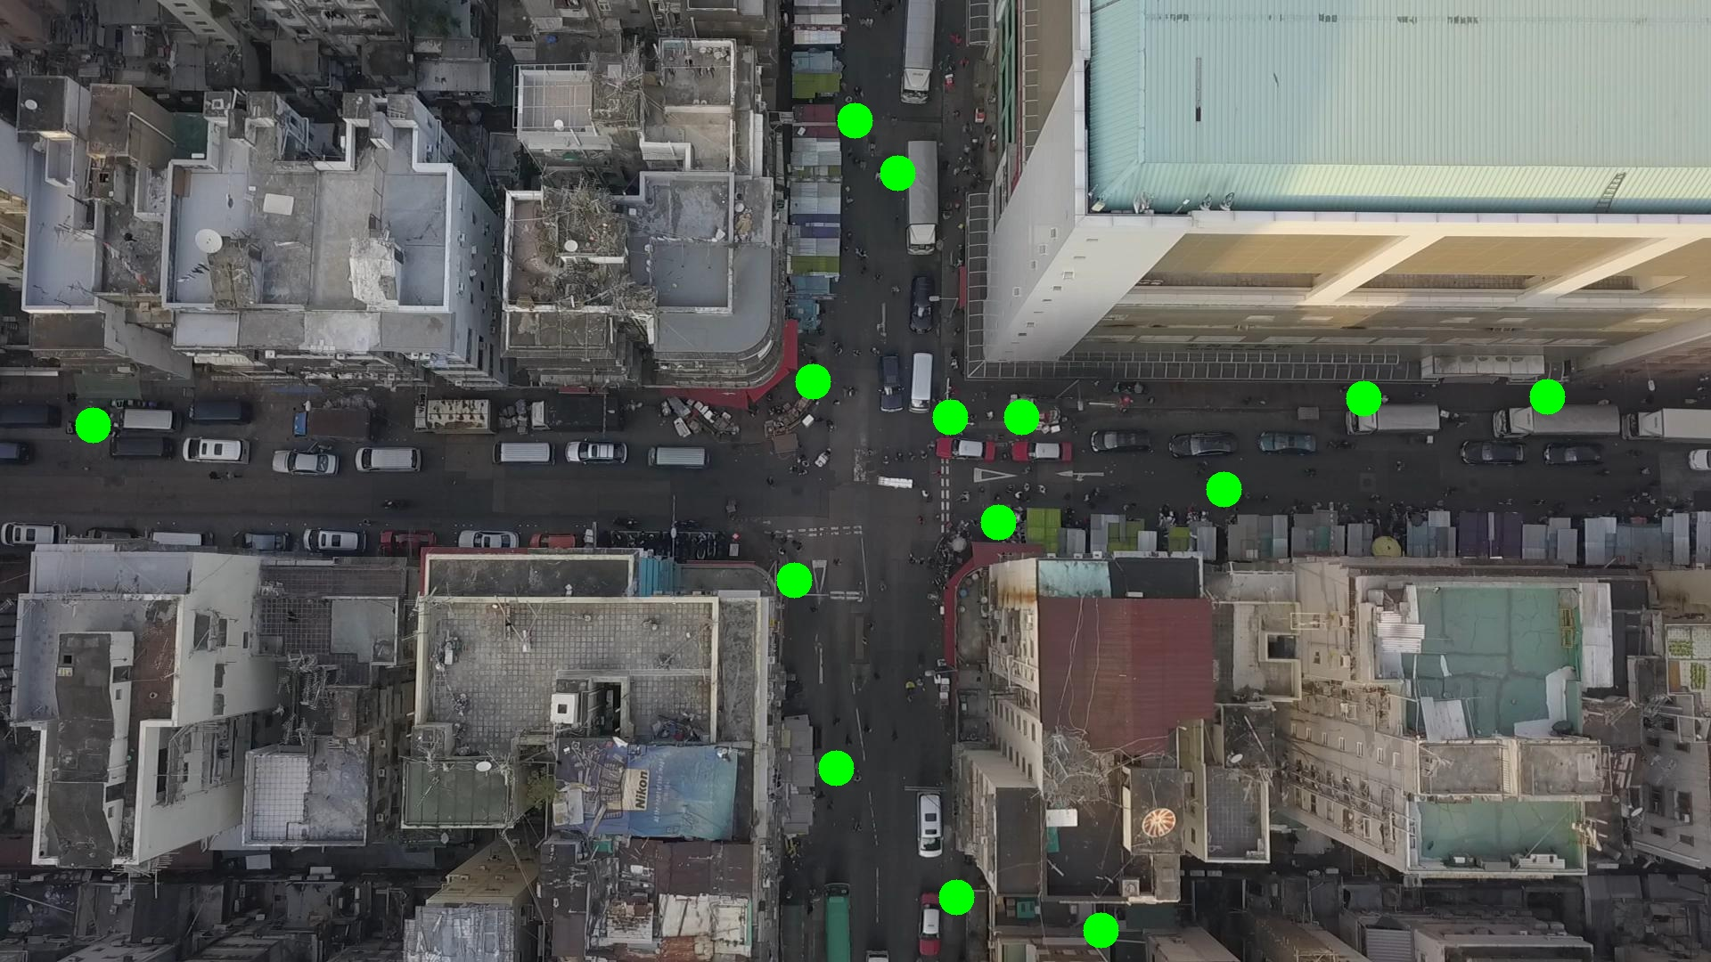

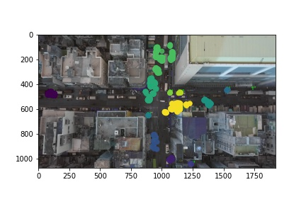

Silhouette metric for img011010.jpg is: 0.5861931414300656

Davies Bouldin metric for img011010.jpg is: 0.3457251251679764

Calinski Harabasz metric for img011010.jpg is: 22369.61718553632

ID 0: (104, 478)

ID 1: (939, 850)

ID 2: (893, 653)

ID 3: (1372, 548)

ID 4: (1066, 468)

ID 5: (1130, 568)

ID 6: (912, 428)

ID 7: (1736, 445)

ID 8: (1530, 447)

ID 9: (968, 297)

ID 10: (959, 135)

ID 11: (1072, 1006)

ID 12: (1237, 1045)

ID 13: (1146, 468)

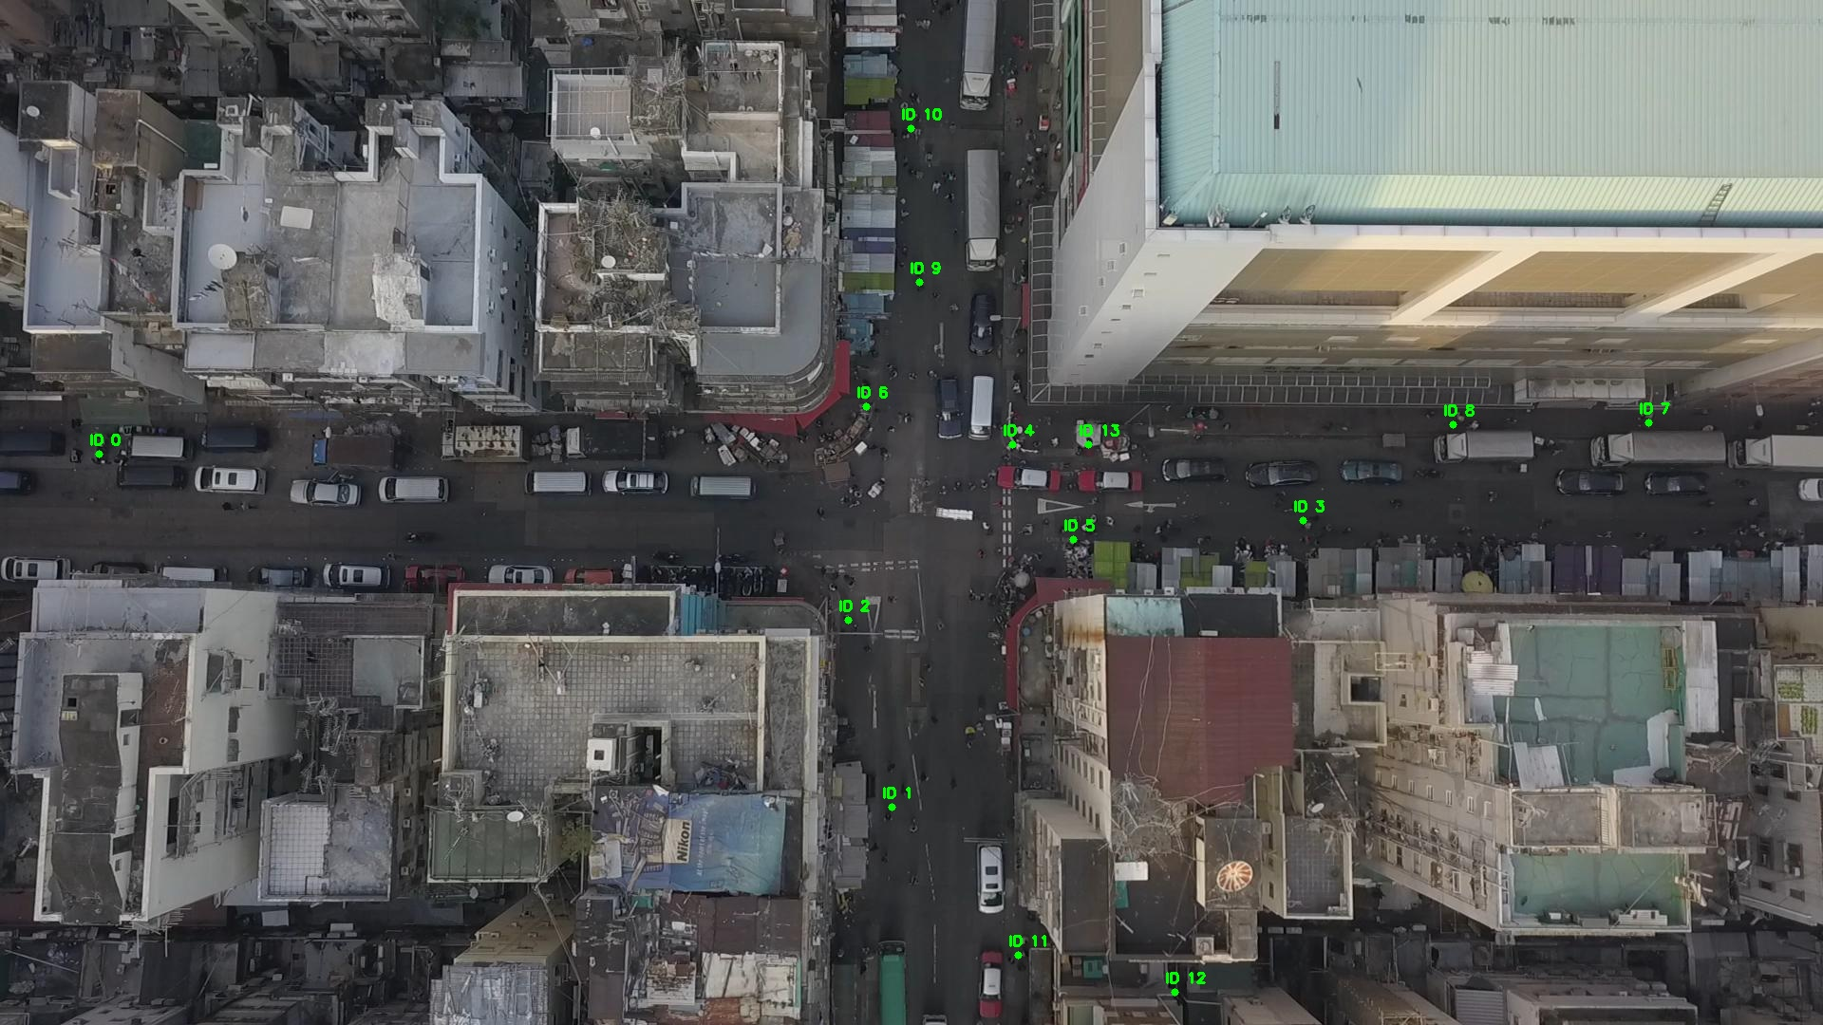

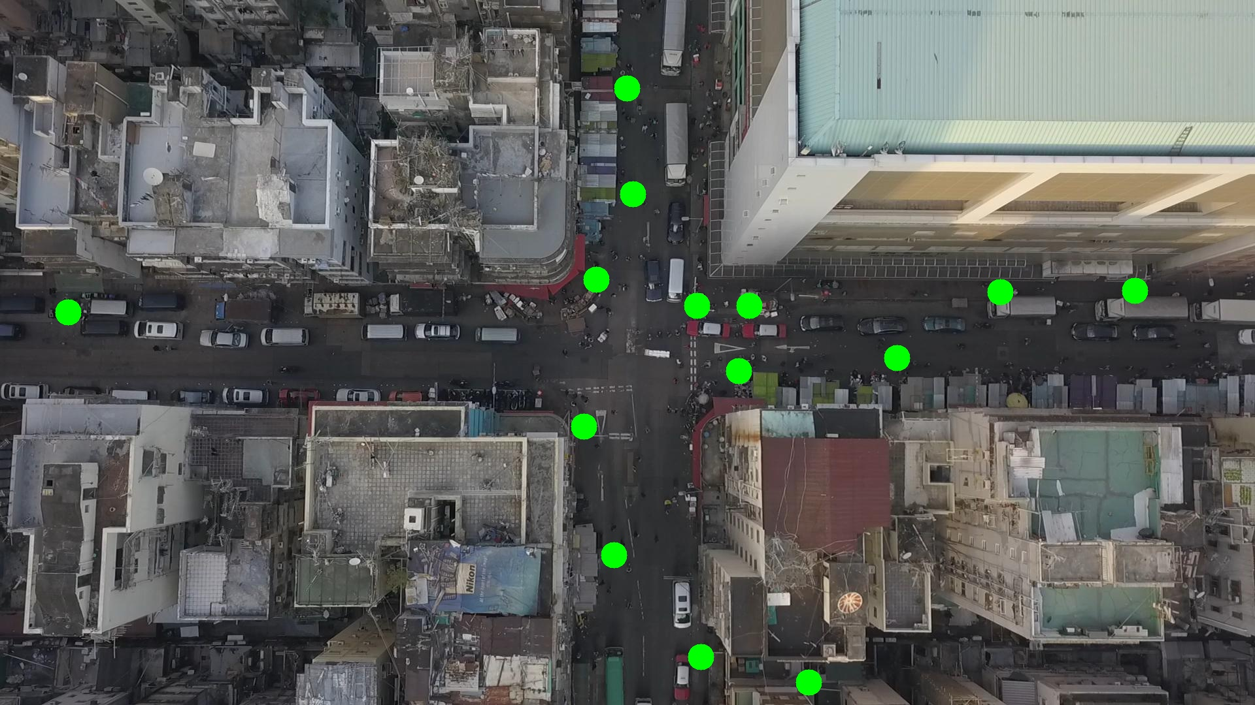

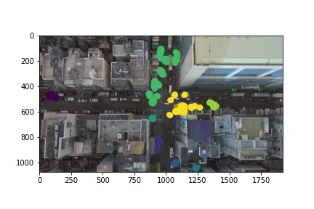

Silhouette metric for img011011.jpg is: 0.4957865831359383

Davies Bouldin metric for img011011.jpg is: 0.39919511071464336

Calinski Harabasz metric for img011011.jpg is: 30193.555936126897

ID 0: (103, 477)

ID 1: (940, 861)

ID 2: (892, 651)

ID 3: (1372, 548)

ID 4: (1032, 510)

ID 5: (1216, 566)

ID 6: (916, 385)

ID 7: (1850, 554)

ID 8: (1530, 447)

ID 9: (968, 297)

ID 10: (1021, 188)

ID 11: (1069, 1010)

ID 12: (1237, 1046)

ID 13: (1146, 468)

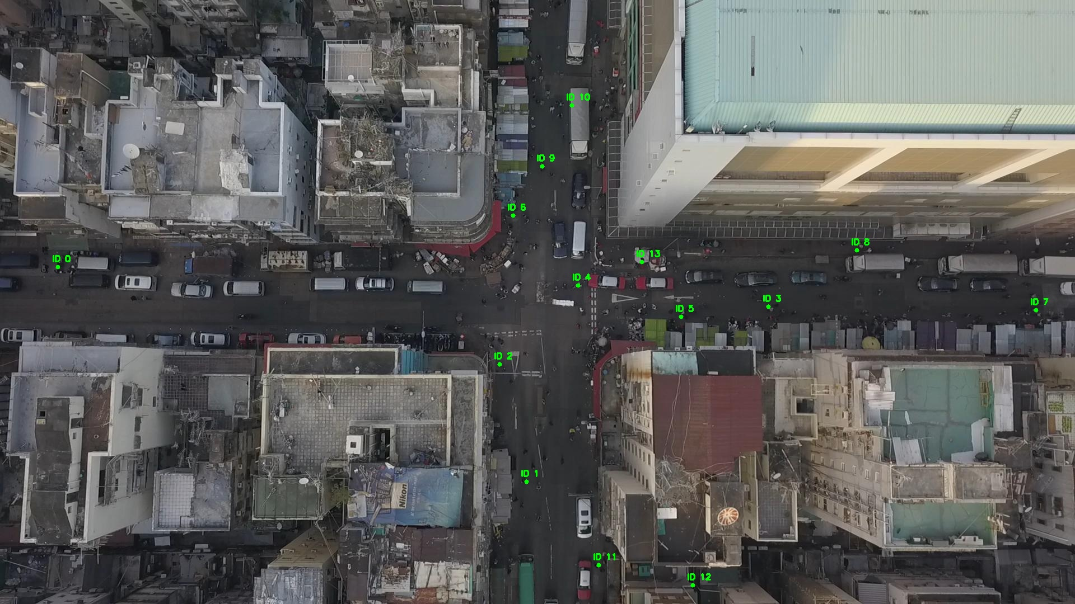

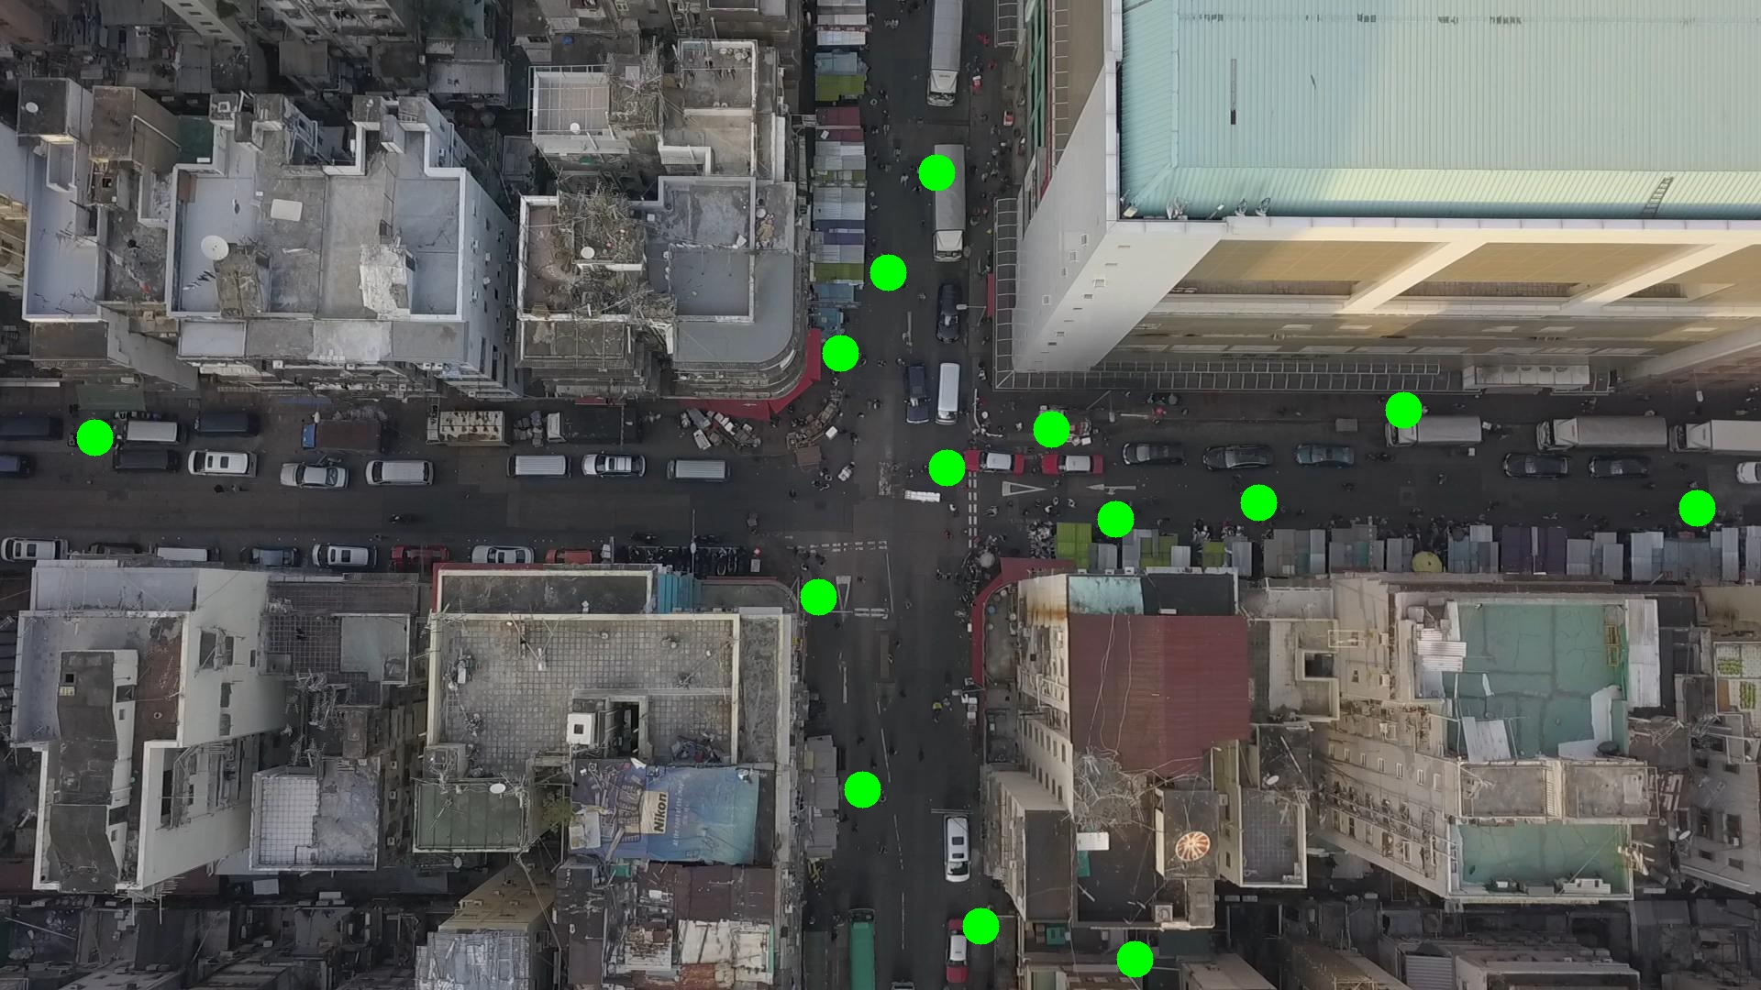

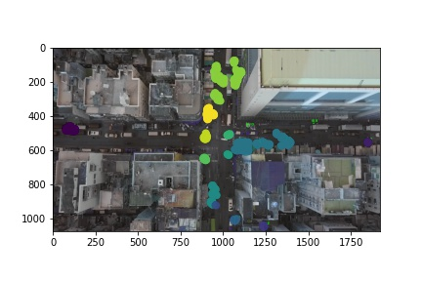

Silhouette metric for img011012.jpg is: 0.6119242080176556

Davies Bouldin metric for img011012.jpg is: 0.3132516524846709

Calinski Harabasz metric for img011012.jpg is: 82036.38445609568

ID 0: (103, 477)

ID 1: (942, 855)

ID 2: (889, 651)

ID 3: (1365, 539)

ID 4: (1065, 467)

ID 5: (1141, 578)

ID 6: (913, 434)

ID 7: (1850, 554)

ID 8: (1530, 447)

ID 9: (962, 284)

ID 10: (1043, 165)

ID 11: (1071, 1007)

ID 12: (1236, 1045)

ID 13: (1146, 468)

